Reverse Momentum (1 Day Lookback)

In this paper we are going to explore a hypothesis I have stemming from stock trading sentiment:

Hypothesis: Equities tend to be oversold on the back of a major event (poor earnings, negative news, economic factors).

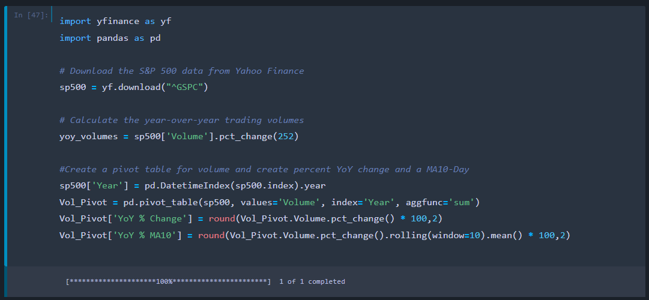The COVID pandemic has stirred sizable retail trading interest, and although that has eased with people returning to work and understanding that being a day-trader is a difficult occupation, retail trading volume still made up 23% of US trading volume in January-22, up from 15% for the same period a year ago(1).

Code

Output

Let’s first look generally at market volumes from people trading the SP500. We use the YFinance API to get trading data for the SP500 and then quickly compare YoY % Changes in volume. We can see varying volume increases, but from a 10Year Moving-Average we can see that volumes are generally increasing (4% YoY on average for the past 10Years).

Even if general trading volumes have increased modestly over the past few years, I believe that the retail market has pushed trading to become more active, decreasing the time between news ingestion, market events, and the trade.

To understand the trading behaviors of equities which have an adverse event occur, let’s back test this hypothesis. We are going to get closing data for all equities listed on the Nasdaq. We will choose a 5-year back testing period, calculate the top 5 worst percentage change performers each day, buy these 5 stocks just before the close of each trading day, then sell them before closing of the next day and repeat this process. We can vary each parameter and understand which criteria generates the highest return, but the understanding is that the equity will be sold off heavily, and bought back mildly the next day by opportunistic investors, pushing the price up from when we bought the previous day.

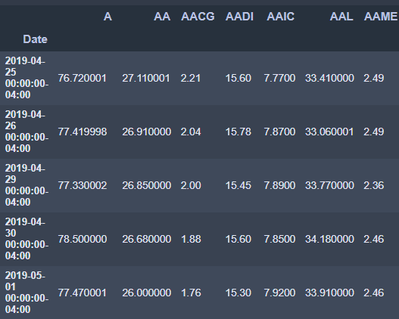

Output

Code

We are going to, again, use the YFinance API to get stock price data. We are initializing the dataframe by asking the loop to create a frame in the first iteration and download the ticker (x==0), and merge all subsequent dataframes (x>0). We are also naming every column with the name of the Nasdaq ticker using the rename function.

Retail Volume (1)

https://www.forbes.com/sites/dereksaul/2023/02/03/retail-trading-just-hit-an-all-time-high-heres-what-stocks-are-the-most-popular/?sh=3ccbdcb56664